CIS 602 – 01: Data Visualization

Project Report

Dennison David (01695825)

Submission Date: 9 May 2017

Dataset:

i. Name :Echo Nest Billboard extracted dataset

URL : https://sites.google.com/site/visualizingahit/preparing-the-data/duplicate_filtered_new.xls?attredirects=0
Description:
- This dataset is in Excel, has been converted to CSV before it is used.
- Dataset of music chart toppers from 1960-2010.
- Contains, but not limited to, Song title and artist, rank, weeks on chart, key, loudness, duration.
- Also contains quantified values for ‘energy’ and ‘danceability’
- Database created using a script in conjunction with the EchoNest API, courtesy Ellis and Engelhardt.
- It contains 4217 entries.
- On closer observation, it is found that data on chart toppers from 1981 and 2006 and missing from the dataset.
- There were also other datasets having data about record sales, etc. but they did not possess any Primary key allowing to merge it together with this set.
- The dataset includes a date for each track, but not in the standard MM/DD/YYYY format, making it difficult to Parse in javascript
- Still, I was able to extract the year from the date and store it as an attribute using Excel.
- Some titles also included double quotations,which posed problems when plugged into the code as an associative array.
- Cleaning the data had to be done manually, since it was impossible to Find and replace using string search.
- Each year had multiple chart toppers, and I had to choose between ordering them by date, or grouping them by year.
- The former turned out un-doable owing to the single digit date and month format used for dates of the songs.
- Grouping by year was eventually what was done.
- The cleaned up data is included in the JS as an associative array

Questions / Tasks to be performed:
- Is there a correlation between Tempo-Sales, Key-Sales, Duration-Sales?
- Is there a relationship between Key-Rank, Loudness-Rank, Duration-Rank?
- As years progress, are any trends noticeable in Tempo/ Duration?
- Identify Trends, Clusters, Outliers and Anomalies.
- Figure out what makes a song peak in popularity
- Identify tracks which held a spot for an extended duration
- Search for clusters that may map to a particular artist/ record label

Process, Components and Techniques:

1) Scatterplot:
- Since these comparisons have 3 quantitative+ 1 categorical(year), I used a scatterplot graph for visualization.
- The 3 quantitative attributes illustrated were BPM, Peak Position and Weeks on chart.
- The Y position of a circle would indicate how upbeat or slow the song was i.e, the BPM.
- The Size of the circle (radius) was influenced by the number of weeks it spent on the chart.
- The color intensity of the circle represents the peak position it attained on the chart.
- Using a filter to select a range of years resulted in choppy results, since the visualization is based on year rather than a linear date flow.
- As a result, I had to add some other elements to show focus. This led me to implement the crosshairs.
- The crosshairs follow the mouse pointer’s position along the graph
- It also highlights any spheres it rests on.
- A tooltip displays additional information about the focused sphere such as title and song artist.
- Visualization idea source courtesy: http://codepen.io/stopyransky/pen/KWomoK

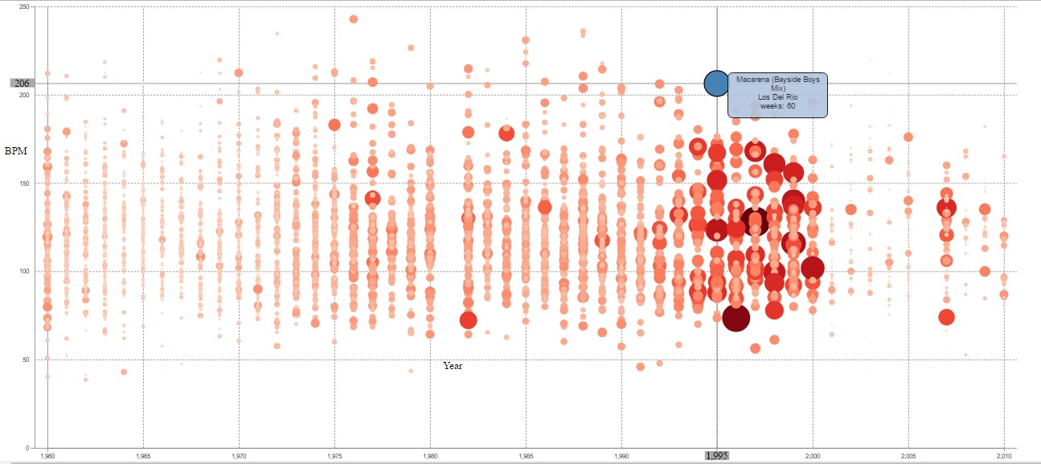
- The marks used in the visualization were the Circles representing each individual song
- The channels used were color intensity (saturation) , position and circle radius.
- The entire visualization was developed using the D3 library.
- BPM is set against the Y-Axis and the Years are set against the X-Axis.
- It can be noted that significant occlusion occurs, but it was the case that any sort of filtering would lead to some sort of incomplete data produced in the visualization.
- The circles are aligned vertically according to their years, instead of being ordered sequentially by date.
- I believe that the crosshairs allow you to obtain accurate BPM values for songs as opposed to approximate values you could guess from the ticks on the Axes.

2) Line Chart:
- The line chart is used to pit a Quantitative attribute against a Categorical one.
- Here, the popularity of the song is scaled along the Y-axis while the Categorical year is positioned along the X-axis.
- The year range is read from the User input using a slider and text box
- I decided to implement a Morris chart for the given dataset
- The circles on the line graph would enlarge when focused on.

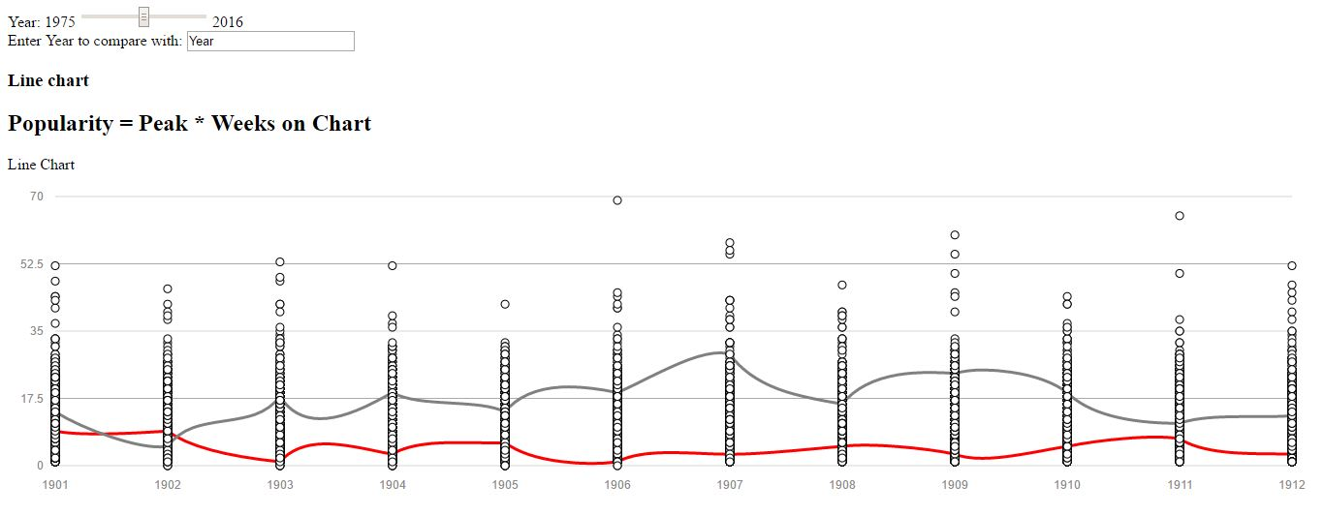
- The marks used are the circles and the two colored lines.
- The channels are position and color.
- The two lines are to compare the popularity trends for 2 years being compared.
- The popularity of each song is a derived attribute calculated based on the peak position and number of weeks on the chart.
- The X axis represents the date within the years, but is mangled owing to the date format inconsistency.
- The Y axis shows the popularity scale along which the songs are compared.
- If the date attributes were parsed correctly, the lines would lie in horizontal patterns rather than vertical.

Task fulfillment:
- The scatterplot graph helped identify a cluster around the years 1992-2000
- It is also noted that the most successful songs of two subsequent years were of very high and very low BPM respectively, followed by one that was right between both.
- Following the trends, those seem to be the most common BPMs that popular songs possess.
- We observe that the songs in the pre-90’s did not hold their chart positions for as long as those in 90’s did.
- There is also a trend where songs with extreme BPMs are absent in the 1960’s and 2000’s eras.

